Press release #11 – June 19, 2017

WITH LOISON, IT’S DOUBLE THE PLEASURE: DINING WITH THE STARS & LOCANDA DI PIERO’S ANNIVERSARY

The warm summer season opens with two large-scale events: on June 25 in Montecchio Precalcino (VI), big celebration in honor of the 25th anniversary of the restaurant owned by Renato Rizzardi. Then, on June 26 in Montegrotto Terme (PD), “A tavola con le Stelle del Nordest”, the 7th edition of the charity dinner featuring Michelin-starred chefs.
At both of these remarkable events, Loison Panettone will be available for tasting in many forms, including lollipops, macarons and two new desserts created by Chef Rizzardi

Two events are opening the summer season: both will feature the one-of-a-kind taste of Loison Panettone.

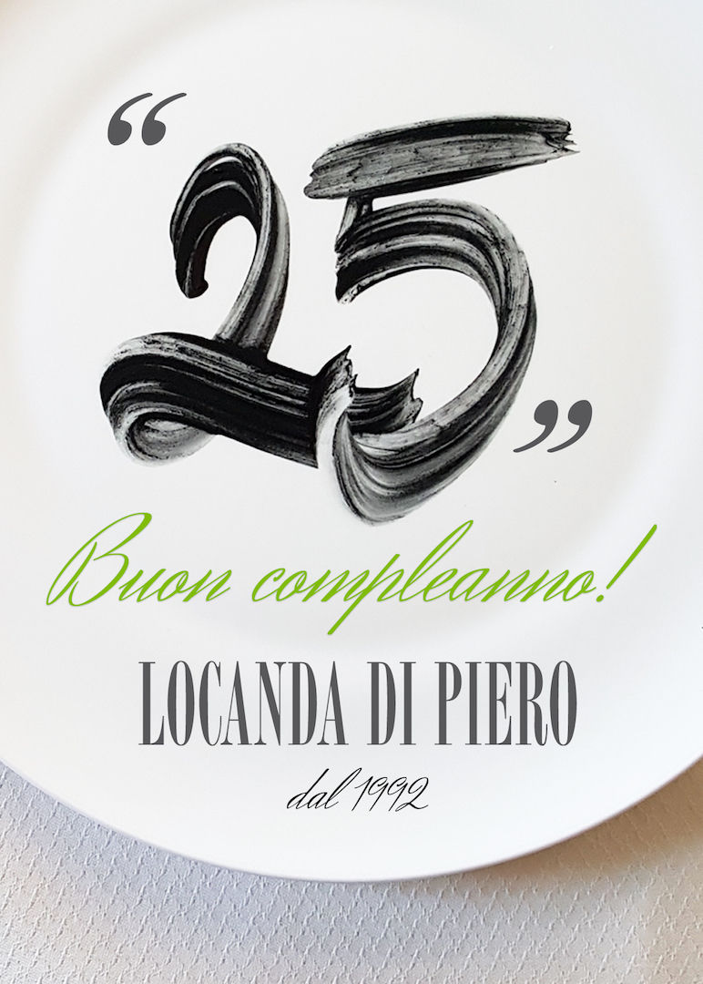
To begin with, on June 25, restaurant Locanda di Piero in Montecchio Precalcino (VI) will celebrate its 25th anniversary. Invited to celebrate the quarter-of-a-century milestone are friends who partner to create artisanal flavors. Dario Loison and his one-of-a-kind products will be there too. Renato Rizzardi, chef and owner of the restaurant, will interpret Panettone into two new
desserts:
- Affogato al Rum with Loison Classic Panettone
- Opera, featuring Mandarin Panettone, marmalade & dark chocolate
The latter is a delightful combination of flavors and tastes. One of the featured ingredients is “Gagliardo Triple Sec Radicale”, a citrus-infused product by Distilleria Schiavo in Costabissara (VI).
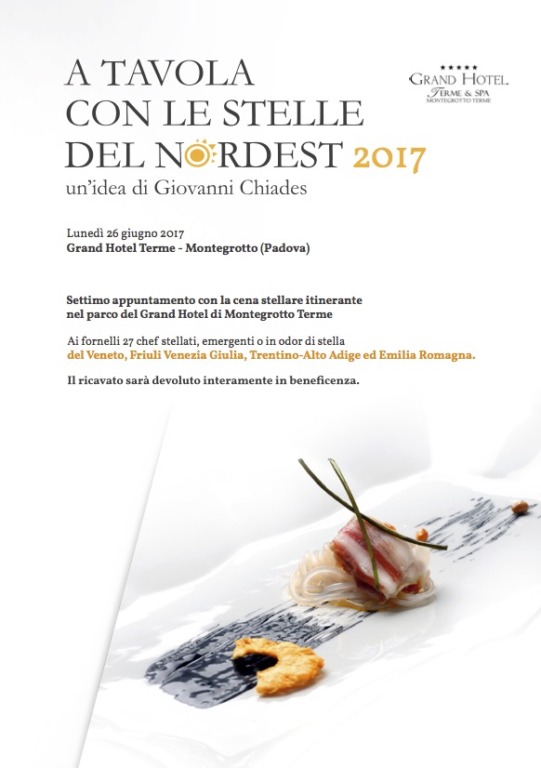
On June 26, the “A tavola con le Stelle del Nordest” (Dining with the Stars of the Northeast) dining event will be hosting its 7th edition. Preparing the themed dinner in the park of the Grand Hotel in Montegrotto Terme (PD) will be 27 Michelin-starred, or soon to-be starred, chefs from the Italian regions of Veneto, Friuli Venezia Giulia, Trentino Alto Adige and Emilia Romagna.
The sweet taste of Loison, which is always first in line when it comes to charity events, will be made available through samples of Rose Panettone. This sweet yeast bread is made with a special blend of roses, including the Damask Rose, and with the precious Ligurian Rose Syrup, a Slow Food Presidium. The recipe for the latter is based on an old and celebrated tradition that dates back to the 1600s.
Next to tradition, we’ll also find innovation thanks to fine Panettone-based pastries. There will be samples of cute Licorice & Saffron Lollipops and of prized Macarons featuring fruity flavors, such as Mandarin and Tart Cherry.
Press Info
press@loison.com
Anna Bottazzo +39 0444 557082, ext. 420
Giulia Marruccelli +39 347 0452739
Dario Loison +39 348 4106615
www.loison.com - press.loison.com - shop.loison.com
www.insolitopanettone.com - museum.loison.com
   

