Press release #14 – September 28, 2017

LOISON MUSEUM AND THE SPICE ROUTES: AN EXOTIC JOURNEY INTO TASTE AND CULTURE
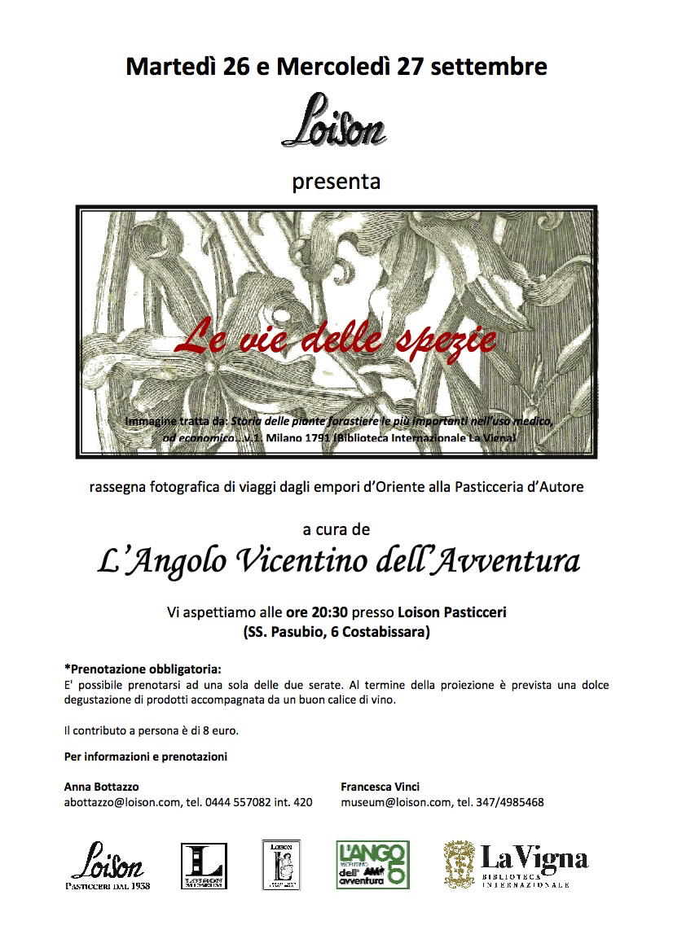
Two events dedicated to the world of spices took place on September 26-27 at the Loison taste lab, thanks to the support of the association “Angolo Vicentino dell’Avventura” and the patronage of international library “La Vigna”.
The extensive photographic review centered around the caravan routes that helped disseminate new knowledge and flavors imported from Asia and the Middle East

On September 26-27, 2017, the Loison Museum became the meeting point for culture, history and photographic narrative with a two-evening event entitled “Le vie delle spezie” (The Spice Routes). Organized by Angolo Vicentino dell'Avventura, with the patronage of international library La Vigna, the venue provided the space for an exotic journey into the scented world of spices.
Dario Loison’s welcomed guests and introduced the topic by explaining about his infinite passion for spices and his extensive research on Madagascar vanilla. His presentation was followed by those of Maurizio Cucchiara, Roberto Virgili and Daniele Giaretta, members of the aforementioned association of travelers. They offered an in-depth photographic review of the caravan and shipping routes through which spices, new tastes and flavors, as well as ideas and beliefs, arrived from Asia and the Middle East, traveling thousands of miles across scorching deserts and impassable mountain ranges. The merchants’ efforts contributed to creating emporiums, markets and cities in the western world. The fascinating images and narratives offered by Angolo Vicentino dell'Avventura were full of powerfully evocative impressions.
Next was Francesca Vinci, spokesperson for the Loison Museum, who emphasized the importance of Venice and its monopoly of the spice trade. Vinci enriched her narration with videos and images of the lagoon, the “calli dei spezier”, or spice alleys, the Rialto and the Venetian confraternities.
Theory was followed by practice, when the guests had the opportunity to taste - first with their sense of smell and then with their mouth - all the wonderful fragrances of the spices exuding from delicious samples of Veneziana with late Mandarin from Ciaculli (a Slow Food Presidium), from Licorice & Saffron Panettone and from Rose Panettone. Alongside these scrumptious treats there were delicious Macarons featuring Tart Cherry Panettone and Lollipops made from Licorice & Saffron Panettone. Thanks to sommelier Daniela Mura, the tasting was accompanied by two great wines: Bellussi Prosecco di Valdobbiadene Docg Dry - vintage year 2016 - and Verduzzo Soandre Passito Doc from Lison Pramaggiore.
Two evenings in Loison’s taste workshop dedicated to the pleasure of culture and the taste for sweet confections.

Press Info
press@loison.com
Anna Bottazzo +39 0444 557082, ext. 420
Giulia Marruccelli +39 347 0452739
Dario Loison +39 348 4106615
www.loison.com - press.loison.com - shop.loison.com
www.insolitopanettone.com - museum.loison.com
   

