Press release #6 – June 10, 2019
Dario Loison receives Best Gourmet Alpe Adria Award for best traditional cake at gala dinner in Jesolo
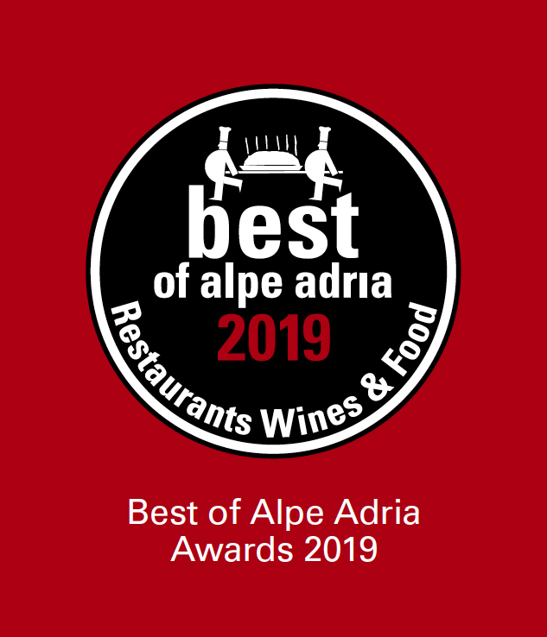
Loison’s Chocolate & Spices Veneziana wins the award that will be bestowed during the highly anticipated event held on June 13 at TerrazzaMare Marcandole in Jesolo.
The renowned food and wine guide has been a point of reference for the haute cuisine of the Alpe Adria region for the last 23 years

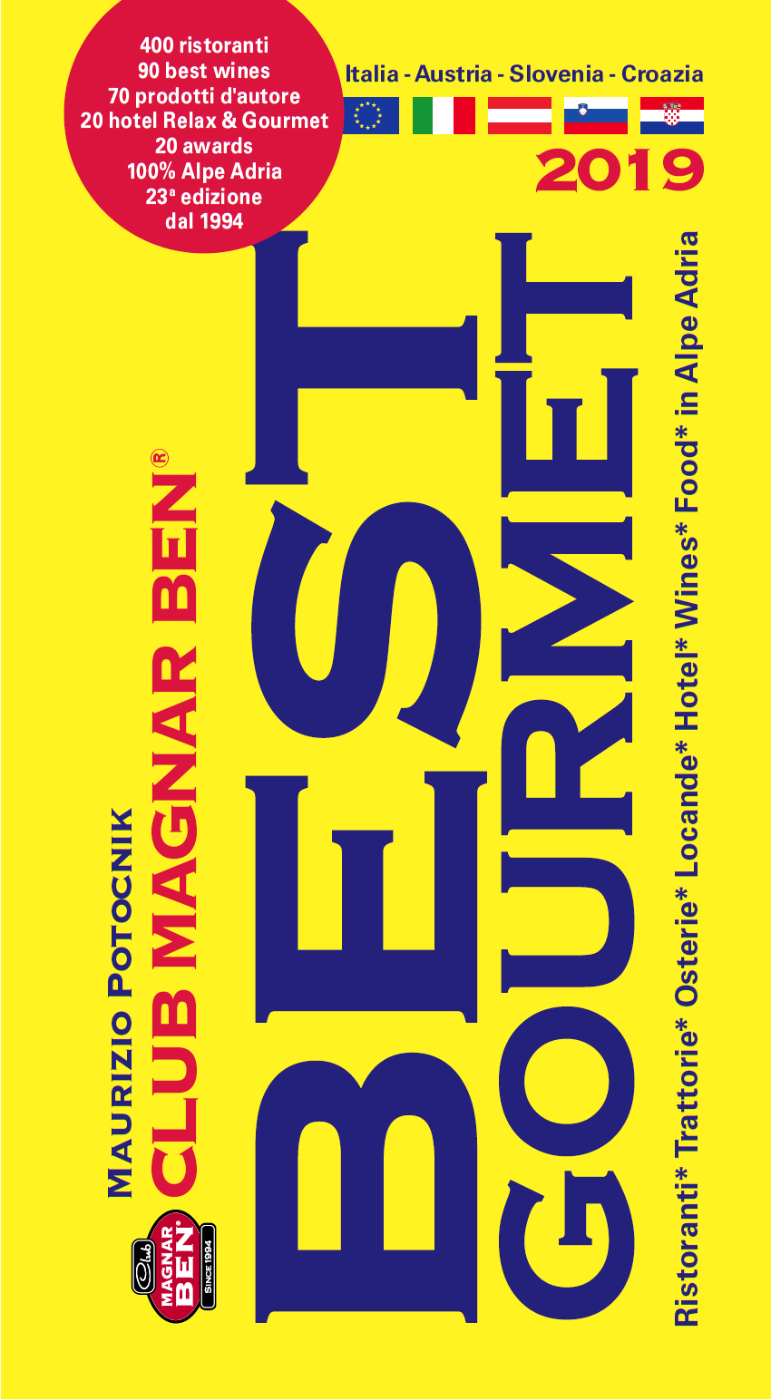
We first announced here and it’s now almost time to join in the celebrations for the 2019 Best Gourmet event honoring the food and wine industries of the Alpe Adria region. The organizer of the 8th edition of the award ceremony is once again food and wine publisher Maurizio Potocnik.
The highly anticipated event that focuses on the Alpe Adria region - comprising the European countries of Italy, Austria, Slovenia and Croatia - will be held on June 13 at TerrazzaMare Marcandole in Jesolo, Venice.
The award ceremony will take place in the evening when, in front of an audience consisting of Italian and international journalists, the 20 winners of the 23rd edition of the Best Gourmet Guide will be recognized. In the Food category, this year’s award for best traditional cake went to Dario Loison for his Chocolate & Spices Veneziana.

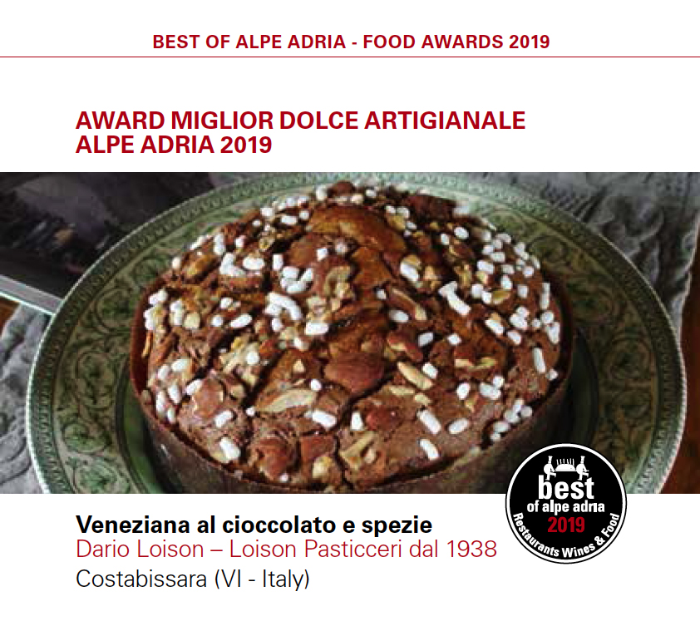
This version of the traditional Venetian sweet bread features selected single-origin cocoas, mainly from Cuba and Venezuela. In addition to decadent chocolate morsels, the confection includes a skillfully balanced mix of choice black pepper from Lampong, Indonesia, from Timut, Nepal, and from Jamaica, for the right amount of depth and spiciness. It’s not all: the pepper has also been expertly combined with Tonka beans, whose notes remind us of bitter almond, and the delicate fragrance of Mananara vanilla from Madagascar (a Slow Food Presidium) and turmeric powder from Asia.

The award ceremony will be followed by a Grand Gala Dinner prepared by 12 champions of taste who will work in teams - Jesolo vs. Alpe Adria - challenging one another on surf and turf dishes. It will be interesting and entertaining to see the different creations of the two local teams, each consisting of three elements (2 restaurants and a pastry chef), who will prepare dishes that will be accompanied by different types of wines and gins.
The team representing the city of Jesolo will be made up of: “Cucina da Omar”, featuring Omar and Valli Zorzetto, chef Roberto Bardella with the kitchen brigade of “TerrazzaMare Marcandole”; pastry chef Mauro Pinel of pastry shop “Pasticceria Pinel”. Opposite them, the macro-region of Alpe Adria will be represented by Michelin-starred chef Alessandro Gilmozzi from restaurant El Molin in Trentino, by Ilija Pejic who owns and runs the restaurant located inside the Golf Club of Tarvisio, Udine, in the heart of Central Europe, and by Dario Loison, who will conclude the dinner on a sweet note with a "Fantasia di dessert" inspired by his Chocolate & Spices Veneziana.
The dinner’s wine pairings will include: “Mon” Saten Brut Villa Franciacorta by Moticelli Brusati in Brescia; brand new “Geck” Gewürztramier Trentino DOC by Astoria, recently presented at Vinitaly, “Friulano 2016” by Paolo Rodaro Winery; “Duality” Sauvignon by Vignaioli Specogna del Collio; Gran Rosé Dosage Zero 2015 Metodo Classico; and for the grand finale, a 2014 late-harvest Ribolla Gialla by Villa Parens. Last but not least, Gilbach.Gin, a gin and tonic drink created by Alessandro Gilmozzi and prepared by the bartenders at TerrazzaMare Marcandole. What a comprehensive panorama of the unique macro-region we know as Alpe Adria!
To see the complete list of awardees, click here.

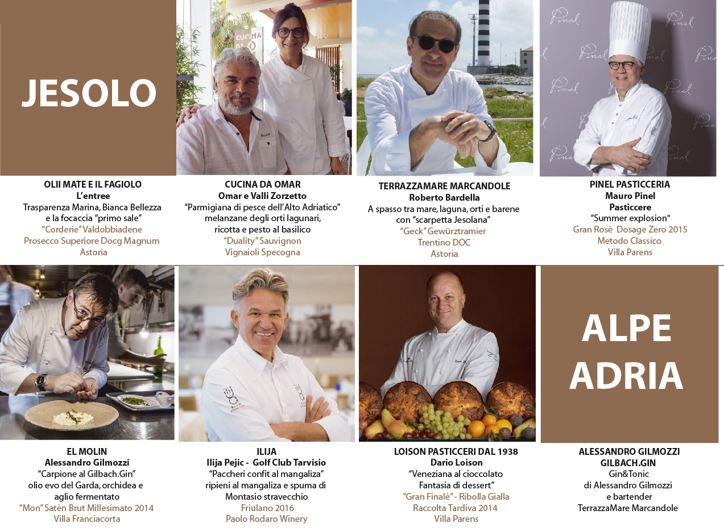
Press Info:
press@loison.com
Giulia Marruccelli +39 347 0452739
Dario Loison +39 348 4106615
www.loison.com - press.loison.com
www.insolitopanettone.com
   

