Press release no. 13 – December 2, 2019

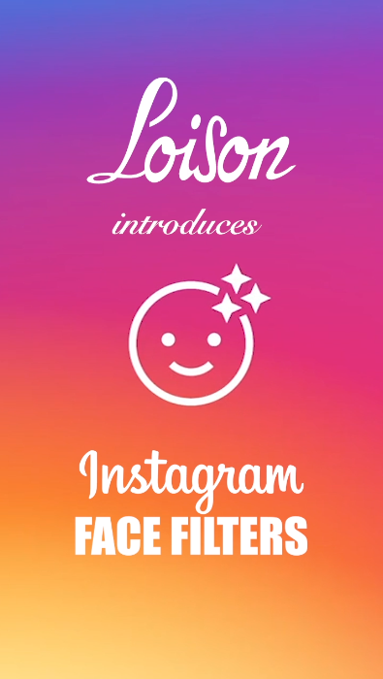
Loison’s new face filter for your Instagram stories!

Last year’s holiday-themed GIFs starring Dario Loison have already reached over 39M views.
This year, Loison is introducing its "Sweet" face filter on Instagram, the most beloved social media app by the younger generations. Users can now add more special effects to their virtual stories.
“For us, it’s another opportunity to promote our brand worldwide in an easy and fun way”

Do you remember Dario Loison’s digital images from last Christmas? The famous pastry chef from Costabissara had fun starring in over 35 GIFs and stickers, including holiday-themed versions and his rendition of “The Scream” by Munch.
A fun activity that has generated well over 39 million views to date. Not bad at all!
This year, Loison Pasticceri are not waiting around and have just added a new signature "Sweet" face filter to their Instagram account.

All of us have, at least once in our lifetime, worn some type of mask. Now with Instagram, we can wear a virtual one by using facial filters, a mask-like augmented reality that adds effects to our own stories. An increasing number of people indeed use filters to personalize images or videos.

How do they work? Go to Loison Panettone’s profile on Instagram and click on the little face icon. This is what happens when you use the new face filter: a virtual Loison logo will land on your cheek, then, if you bat your eyes, cookies will start flying and, finally, if you open your mouth, sweet breads will begin pouring out. Fun, isn’t it? But that's not all: you can also save the face filter to your Instagram camera by clicking on the button that you’ll find when you try the filter for the first time.
It’s easier than you think. Click here and watch the video: you can't go wrong!

“Through Instagram, people of all ages can use their creativity to add effects to their stories - Dario Loison comments. For us, this is yet another way to promote our business and to easily bring attention to our brand while having fun”.

All of Loison’s digital and communication innovations are designed and created by a dedicated team of people whose job is to work on the social media scene alongside traditional strategies. Constantly abreast of the latest developments, Dario Loison does looks ahead, but still remains faithful to the traditions that his family-run business has built over 80+ years.

Press Info:
press@loison.com
Giulia Marruccelli +39 347 0452739
Dario Loison +39 348 4106615
loison.com ~ insolitopanettone.com ~ biscottiloison.com ~ press.loison.com ~ museum.loison.com
#TasteLoison @loisonpanettone

