Press release #18 – Nov. 3, 2020

Loison receives 4 WineHunter Awards at the Meran Wine Festival

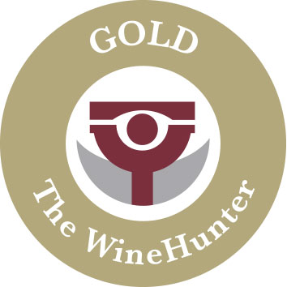  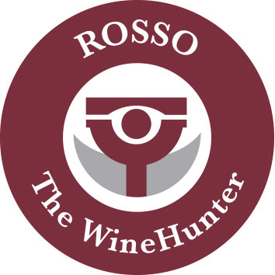 | Only the long-lasting credibility of a baking company with an oven that has been burning since 1938 can make a craft product shine brighter. The awards went to: Panettone Agrumato, Pandoro al Caramello Salato, Sbrisola al Pistacchio and Filone Pera e Spezie

The credibility of Loison as producers of artisanal baked products is recognized not only by the constantly increasing size of their Italian and foreign market shares, but also by the actual awards that the pastry makers receive year after year, including the Wine Hunter Awards of the tasting committees of the Meran Wine Festival headed by its founder Helmuth Kœcher. Below are the products that recently received such honor.

The Panettone Agrumato, featuring five different kinds of candied citrus peel (i.e. two Slow Food Presidia: Chinotto from Savona and late-harvest Mandarin from Ciaculli; citron; lemon; orange) and the Pandoro al Caramello Salato, filled with a salted caramel sauce that is 100% Made in Loison. Each of these yeasted cakes brought home the GOLD WineHunter Award for the second year in a row.

Next to the above award-winning holiday sweet breads, two more Loison products were honored for the second year in a row, this time with the RED WineHunter Award: the Sbrisola al Pistacchio, featuring exclusive pistachio nuts from Bronte, Sicily, and dough rolled out by hand; and the Filone con Pera e Spezie, featuring pear and spices in a loaf-shaped cake prepared according to Loison’s family recipe dating 1969.

The testament to Loison’s excellence is exemplified by the number of WineHunter Awards that the pastry makers’ specialties have received over the last four years:

2019 - Loison garners four Wine Hunter Awards at the Meran Wine Festival
2018 - Meran Wine Festival: Loison is showered with awards
2017 - 12 years at the Meran Wine Festival are well worth three Wine Hunter Awards
2016 - Merano Culinaria Awards: Loison brings home four of a kind
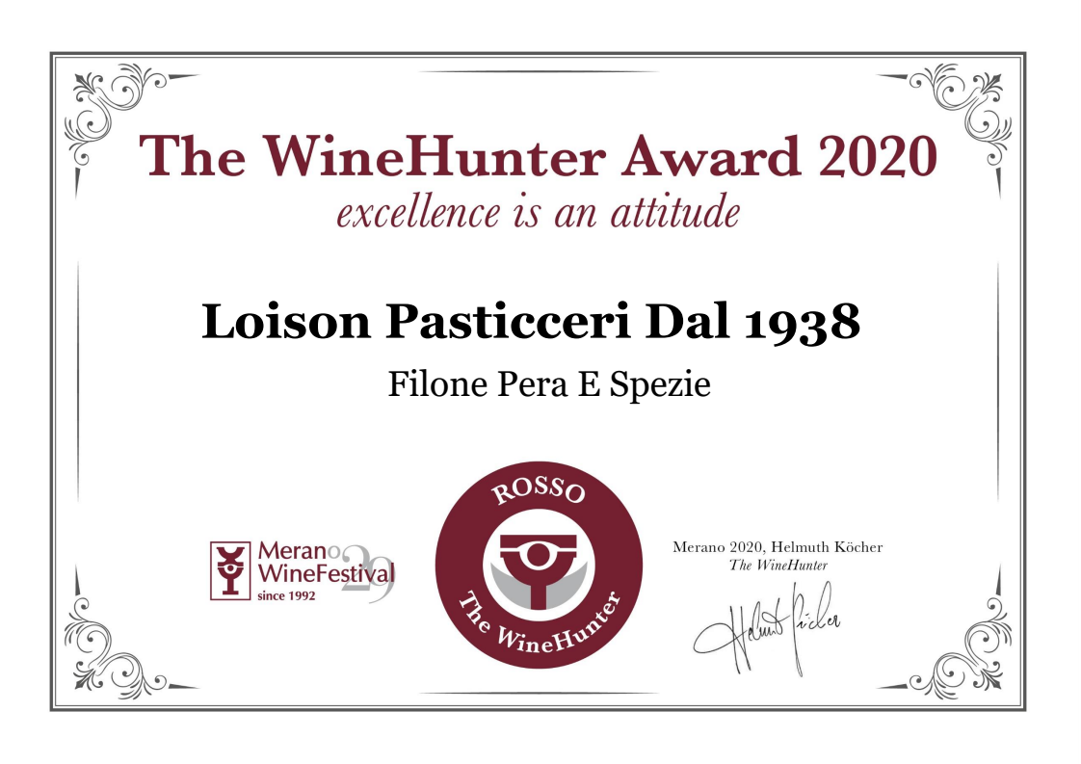
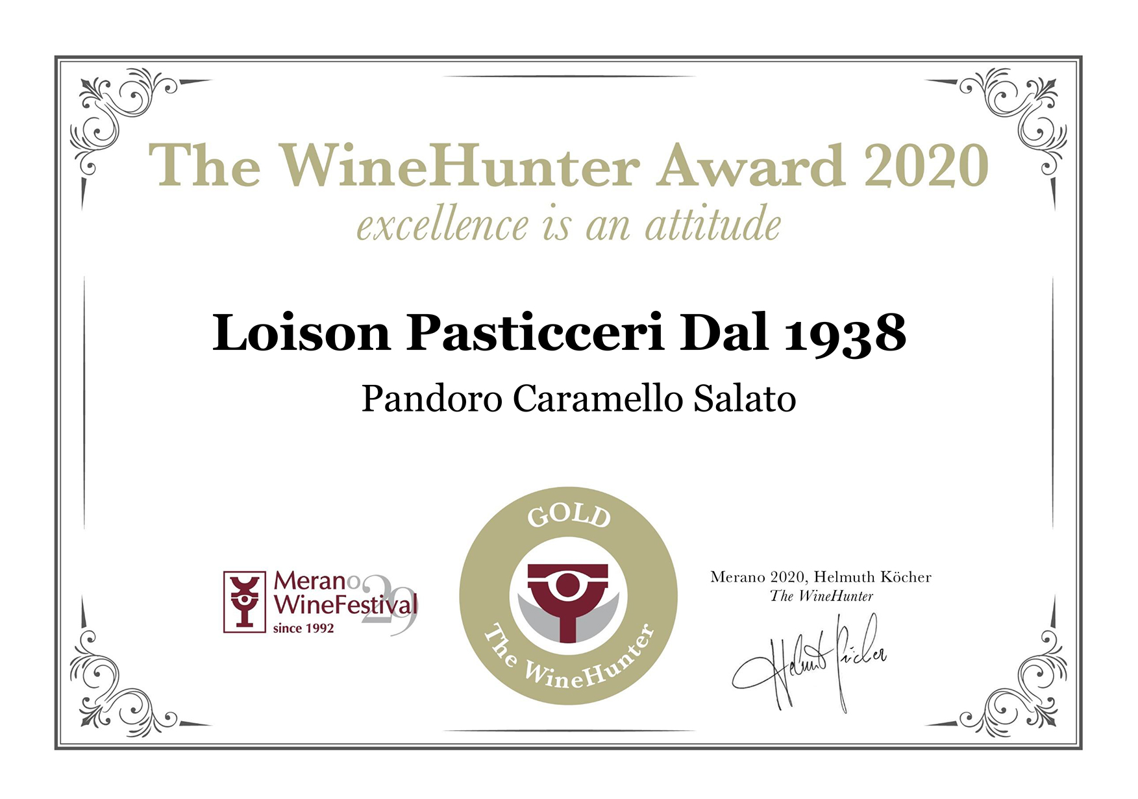
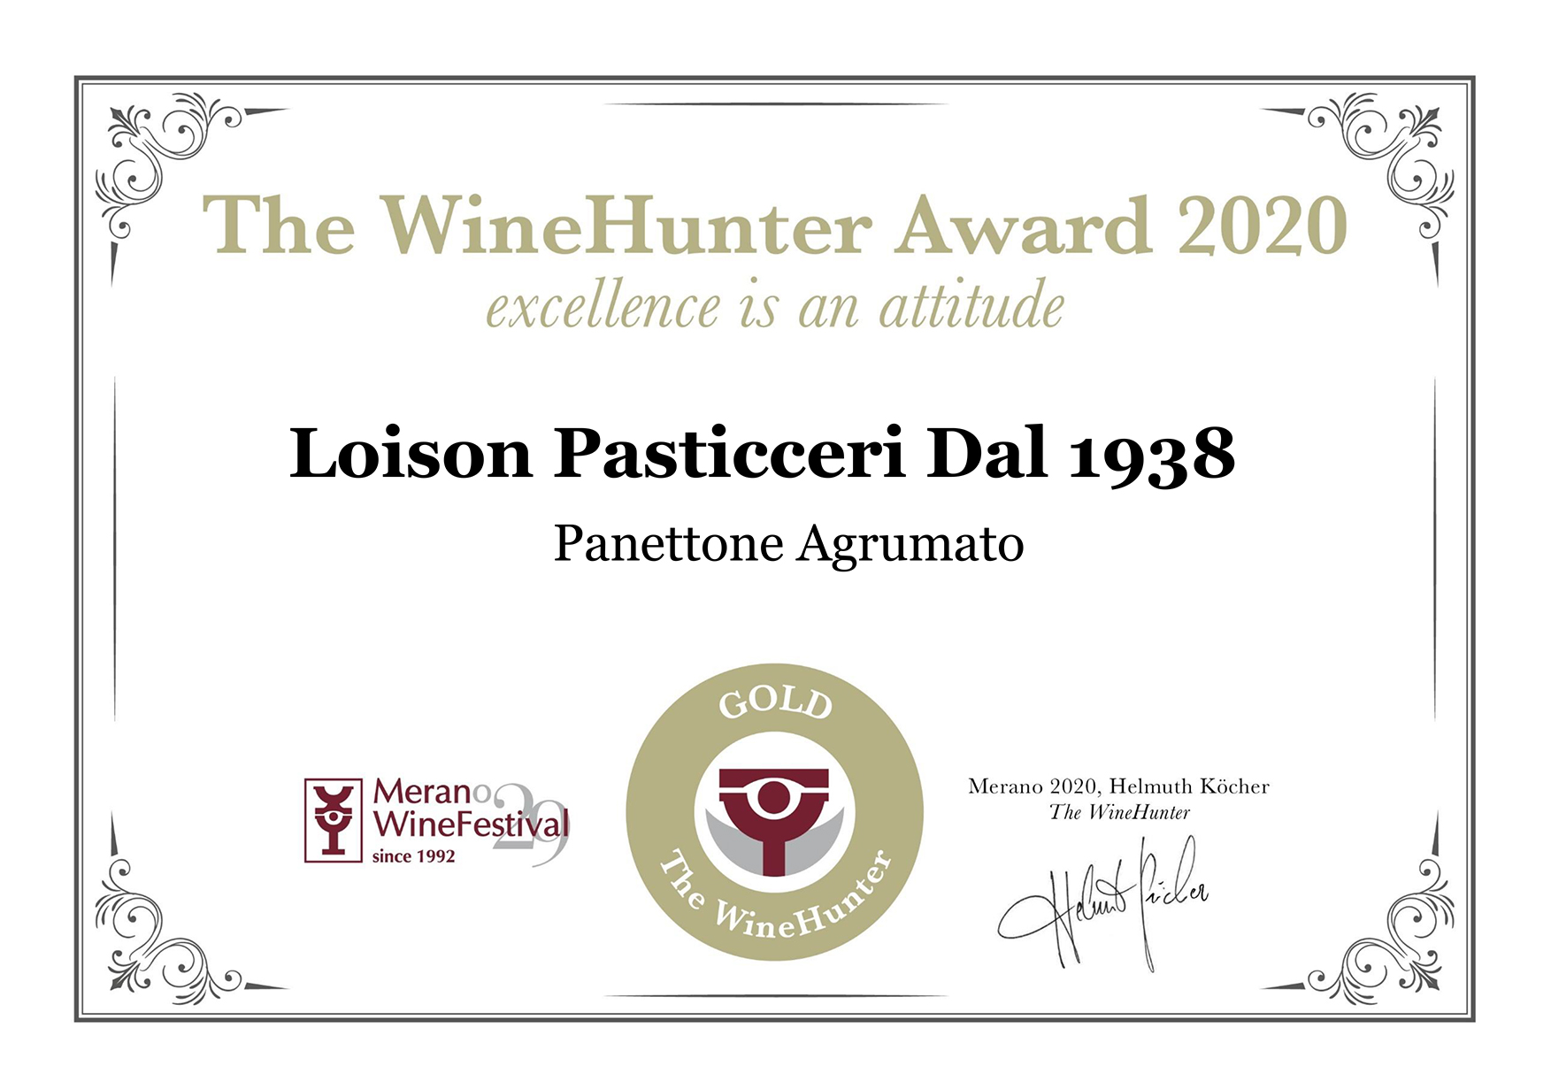

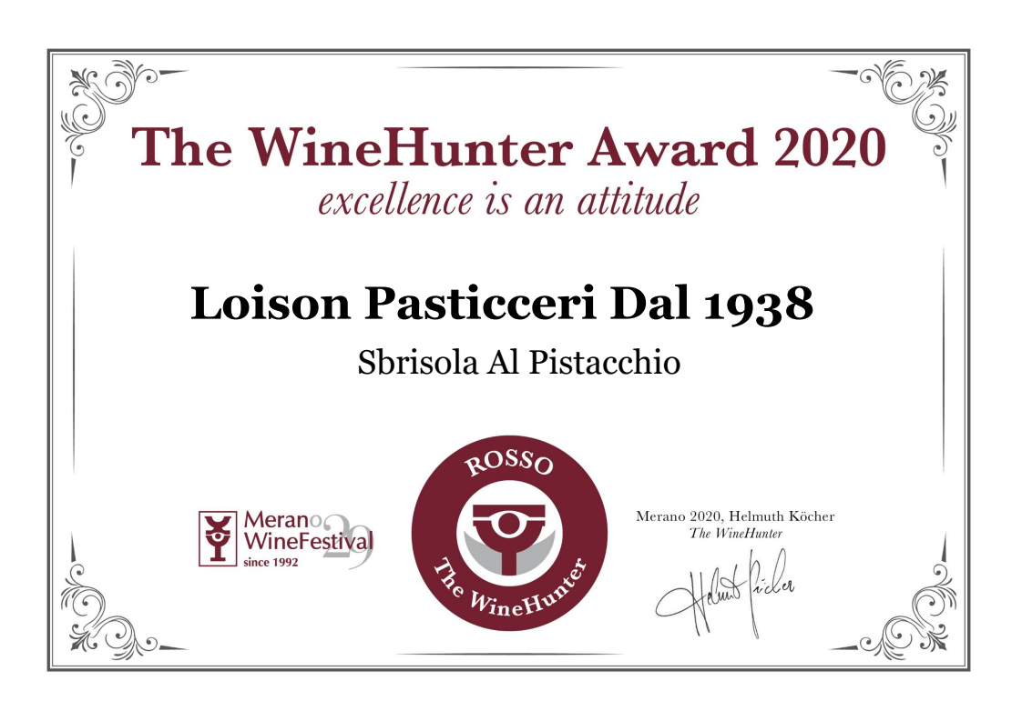

Press Info:
press@loison.com
Giulia Marruccelli +39 347 0452739
Dario Loison +39 348 4106615
www.loison.com - press.loison.com
www.insolitopanettone.com

