Press release #19 – Nov. 5, 2020
Loison’s new website: informed and transparent communication since 1996

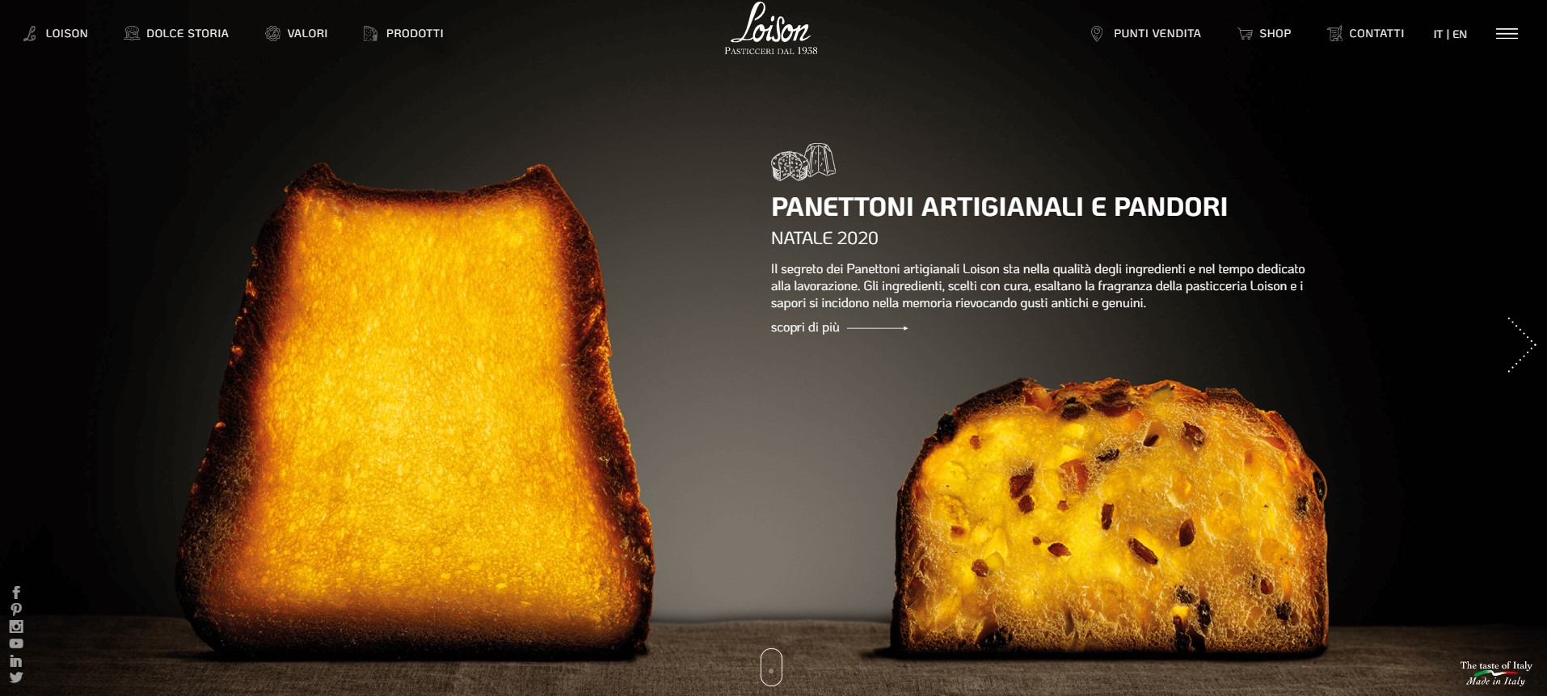
The new website was created to be even more responsive, therefore better adapting to all sorts of smartphones and devices.
The graphics fully mirror the 2020 Winter Holiday Catalog, hence communicating in an increasingly coordinated way
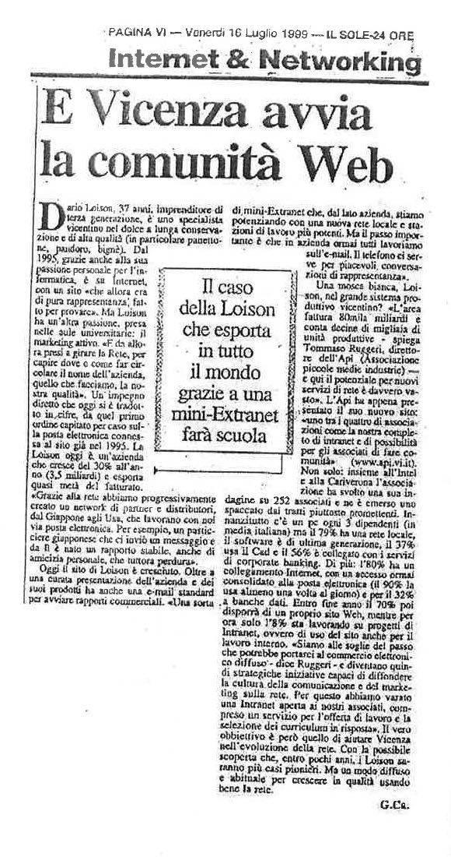
It has been 26 years since the launch of Loison’s first website. Back in 1996, the website consisted of only a few simple pages, though it still managed to pave the way for the baking company to start selling its products online. The first order came from a Swedish housewife who purchased 400 Panettone pieces for the Italian Association in Örebro, Sweden. The second order came from an ice cream parlor called Pinocchio, located in Osaka, Japan.
The first newspaper that told of Dario Loison’s “digital vision” was Il Sole 24 Ore, with an article by Giuseppe Caravita published on July 16, 1999, in the “Internet & Networking” column with the headline “E Vicenza avvia la comunità web” (Vicenza leads the web community).
Over the years, the website has been refreshed numerous times, with the 2020 edition showcasing the following features:

COORDINATED COMMUNICATION
Loison’s communication is increasingly coordinated, as transpired from the consistency between the 2020 Winter Holiday Catalog and the new graphic design of Loison’s corporate website. This format will also be continued with the catalogs to be published in the coming seasons, just like high fashion businesses do. Additionally, the strategy of letting the products speak for themselves - through their ingredients, flavors and packaging styles - is noticeable right away through the design of the homepage.

RESPONSIVENESS
A great deal of development and web engineering work was carried out behind the scenes, in order to get the new Loison website to be highly responsive. The webpages scroll with great flexibility and adaptability, regardless of the device being used, thus providing users with the content they need and ensuring they do not miss out on any valuable piece of information.

CLARITY AND TRANSPARENCY
Like with high-fashion tailored garments that fit perfectly thanks to the skilled work of experienced hands, so was Loison’s website created with extreme care and great attention to detail. From the graphic design to the images and texts across all of the company’s digital spaces, Loison’s goal has always been to provide clear information, so to continue solidifying the relationships with its customers in the name of total transparency, year in and year out.

Press Info:
press@loison.com
Giulia Marruccelli +39 347 0452739
Dario Loison +39 348 4106615
www.loison.com - press.loison.com
www.insolitopanettone.com

