

*Newsletter #3 - July 4-14, 2014*

Dear Gourmand Friends,

with the summer in full swing, Loison’s products did not fail to be present at prestigious culinary events. After [**Cibus**](http://press.loison.com/en/news/462/), here is where else we showcased our confections.

**From America to Italy: Chef Giuliano Hazan meets Loison Panettone**

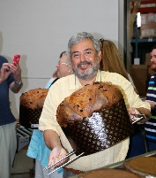The son of **Marcella Hazan** was in the **Veneto** region with the students of his cooking school. They visited Loison and all raved about a truly artisan Panettone we make. After touring Loison, they moved on to a few more of the best food and wine businesses of the Veneto.

**Dining with the Stars of the North-east, Panettone Cream and Loison’s friends**

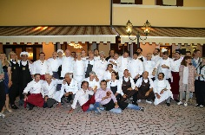The traditional event that brought together Michelin-starred chefs from the Triveneto area of Italy turned out to be very successful. Among the participants were **Paolo Favaretto**, with his divine Baccalà, and **Peter Brunel**, who presented a dish of rice, cabbage and apple stock, trout roe and Loison’s Panettone dust.

**An Evening with a Dream: Loison’s heart and taste**

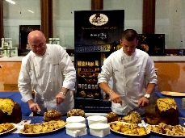The 7th edition of the charity event **“Serata con un Sogno”** (An Evening with a Dream) took place at Cantina Fasoli in Colognola ai Colli. Loison’s confections were there: Veneziane, Panettoni with Calabrian Fig and butter cookies, for over 350 guests. Because life is sweet when we give others a little flavor.

**Parade of chefs in Bolzano: Loison draws the crowds with its Panettone cream**

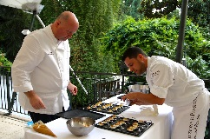On May 26, even chefs and friends Herbert Hintnerand Andrea Fenoglio attended the “**La luna tra le stelle**” event: everybody raved about **Loison’s Cream**, a new and versatile way to eat Panettone all year round.

Here is also a quick **press overview** (in Italian).

* [Come ottenere successo sul mercato? Il caso Loison all’università di Vicenza](http://www.italiaatavola.net/articolo.aspx?id=34321#_blank) - **Italia a Tavola**
* [A Cibus le delizie e le novità del Veneto](http://corrieredelveneto.corriere.it/veneziamestre/notizie/vino_e_cucina/2014/6-maggio-2014/a-cibus-delizie-novita-veneto-223179056630.shtml#_blank) **- Corriere del Veneto**
* [Voci di piccola impresa: le idee anticrisi di Loison](http://www.radio24.ilsole24ore.com/player.php?channel=2&idpuntata=gSLAAhy5f&date=2014-05-04&idprogramma=voci-impresa#_blank) - **Radio 24** - Voci di impresa (podcast)
* [Eccellenze vicentine - Dario Loison, pasticcere artigiano](http://notitiae.jsk.it/user_attach/9/536c9dd9529e3.png#_blank) - **Il Gazzettino**
* [La colomba pasquale antico simbolo di pace](http://notitiae.jsk.it/user_attach/9/5351428d44f91.jpg#_blank) - **L'Adige** – Pantagruel
* [Loison, l'imprenditore dell'artigianalità](http://www.piaceridellavita.com/pdv-club/aziende/1268-loison.html#_blank) - **Piaceri della vita**
* [Loison batte la crisi col panettone salato](http://www.liberoquotidiano.it/news/11590903/Loison-batte-la-crisi-col-panettone.html#_blank) - **Libero** - Liberomercato
* [Loison, grazie ad Internet metà del fatturato con l'export](http://www.repubblica.it/economia/rapporti/impresa-digitale/marketing-multicanale/2014/04/03/news/loison_grazie_ad_internet_met_del_fatturato_con_l_export-82652663/#_blank) – **Repubblica** - Economia & Finanza

Enjoy!

**Press Info:**

press@loison.com

Eleonora Pontello +39 0444 557844

Giulia Marruccelli +39 347 0452739

Dario Loison +39 348 4106615

www.loison.com - press.loison.com

www.insolitopanettone.com  
[](http://www.facebook.com/loison.panettone)  [](https://www.youtube.com/user/loisonpasticceri)  [](http://pinterest.com/loisonpasticcer/)  [](https://it.foursquare.com/v/4d49760819ab2d434b4caa95)  [](https://plus.google.com/108878538706457230755/posts)  [](http://twitter.com/loisonpanettone)  [](http://www.linkedin.com/companies/loison-pasticceri-dal-1938)